 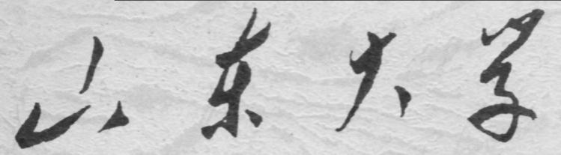

**崇新学堂**

**2022－2023学年第一学期**

实 验 报 告

课程名称： Experiments of Introduction to EECS

实验名称： For Your Eyes Only

专 业 班 级 崇新21

学 生 姓 名 余昊 葛明烨 崔宇鑫

实 验 时 间 2022年11月1日

**Step1:** CMAX to the Rescue

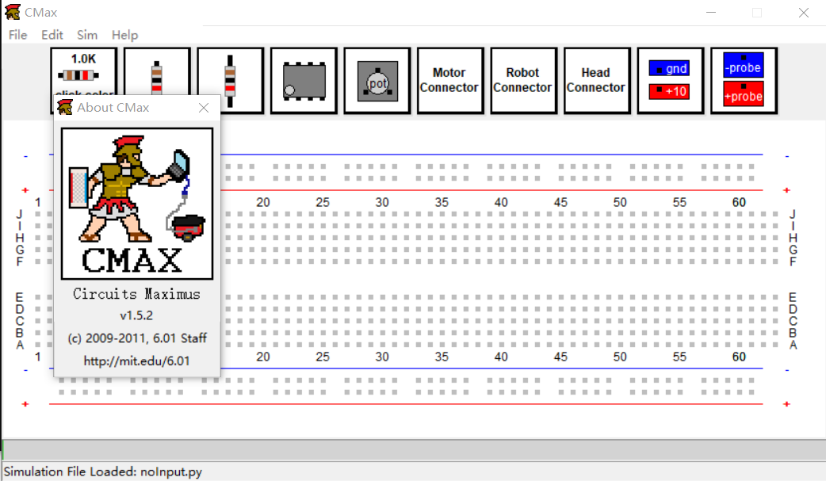(1)Check the version:

(2)The simulation of *mytery.cmax*:

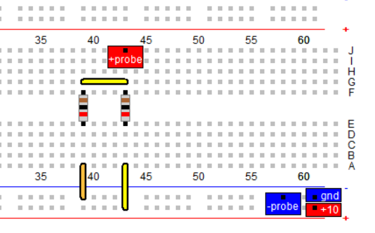

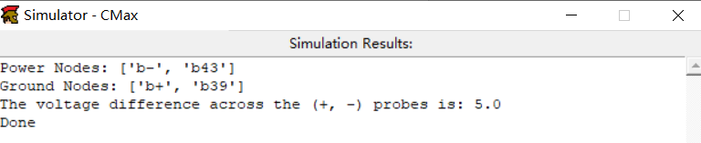

(3)The schematic diagram for the circuit:

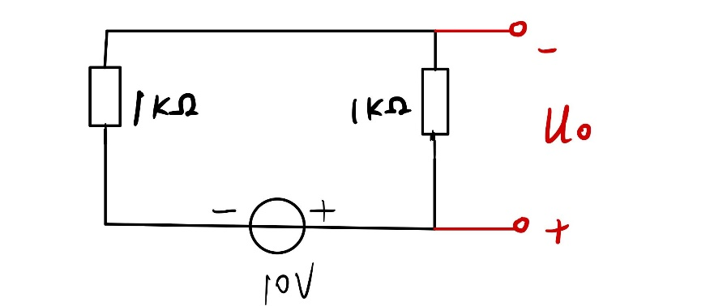

**Step2:** Voltage Dividers

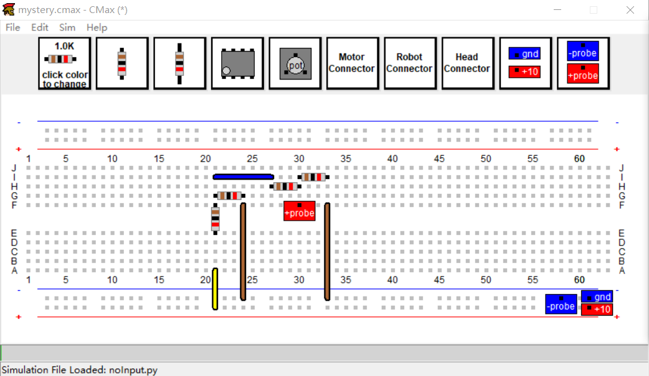(1)Lay out the circuit using Cmax:

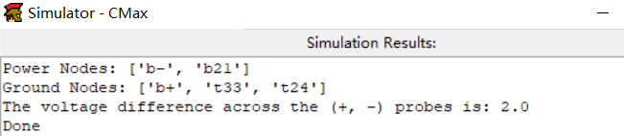

*Check Yourself 1: what is the simulated value of V0?*

*V0=2V*

*Check Yourself 2: Calculated V0 using circuit theory:  
V0=2V*

Explanation:

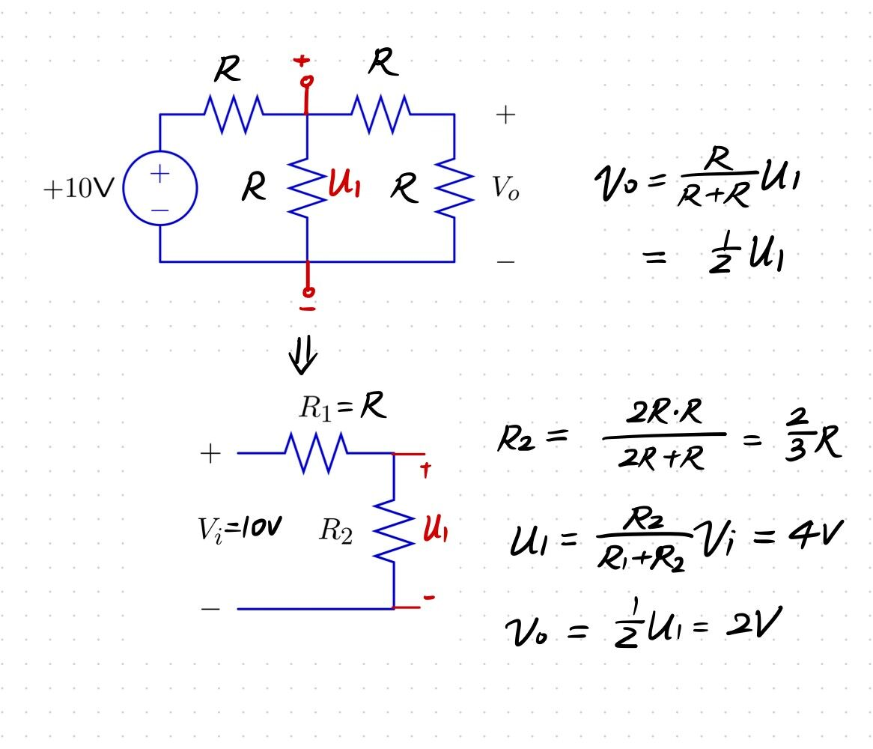

(2)Lay out the circuit with physical parts

*Check Yourself 3: Measure Vo with your multimeter.*

***·****By measuring Vo with a multimeter,we exactly get the same Vo(2V)*

*Checkoff1:Explain the reason why two voltage dividers connected in cascade do not produce an output that is one quarter of the input voltage.*

***·****When we use two voltage dividers connected in cascade,* *the voltage(V1) on the first stage divider is no longer Vi/2* *due to the load effect of the second stage voltage divider.Instead,* *because of the trait of* *parallel resistance, V1 is smaller than Vi/2.We need to calculate the value of the resistance in parallel,and divide the voltage(Vi) between this resistance and R1 to get the correct value of V1.*

**Step3:** Potentiometer:   
*(1) What are the min and max voltages at the middle terminal of the potentiometer?*

*0~10V*

*(2) Adjust the potentiometer (the one you just put on your protoboard, not the knob on the power supply) so that the voltage on the middle terminal is 2.0V. To what value of α does this correspond?*

*α=0.2*

*(3) Leaving the pot adjusted as it was in (2), attach a 100Ω resistance between the middle terminal of the potentiometer and ground. Measure the voltage Vo at the middle terminal.*

*Vo=0.22*

*(4) Use circuit theory to compute the ideal value of Vo in this circuit.*

*Vo=*

*(5)* *Leaving the pot adjusted as it was in (2), remove the 100Ω resistance and attach a 10KΩ resistance between the middle terminal of the potentiometer and ground. Now what is the voltage Vo at the middle terminal?*

*Vo=0.182*

*(6)Use circuit theory to compute the ideal value of Vo in this circuit.*

*Vo=*

*Explanation for (4) and (6):*

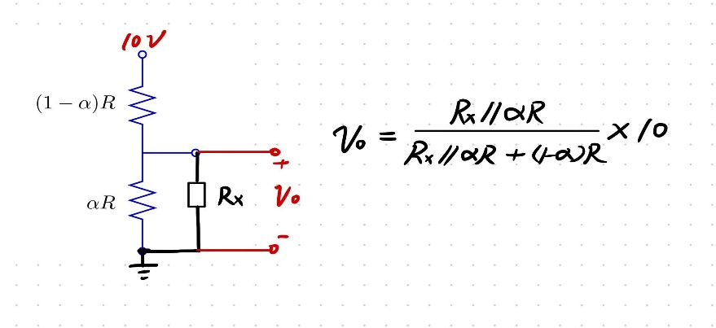

*Wk7.1.2*

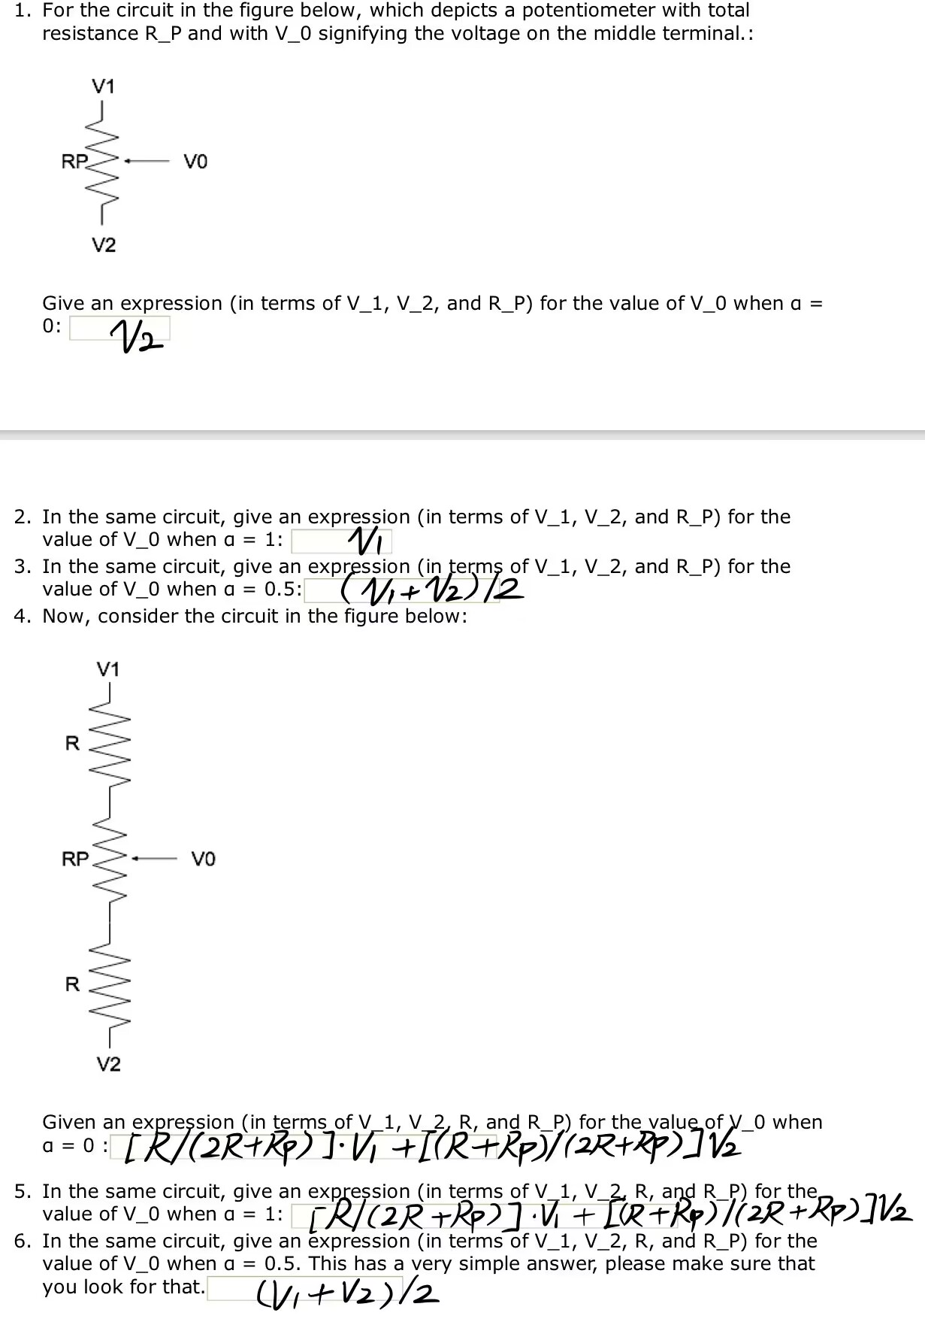

**Step4:** Seeing the light:

*(1)Measure the resistance of each photoresistance(the scale is marked K*Ω)

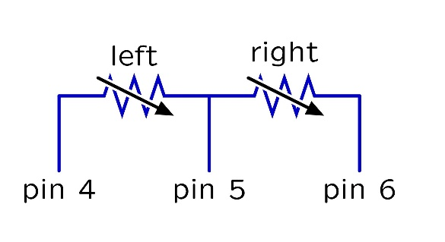

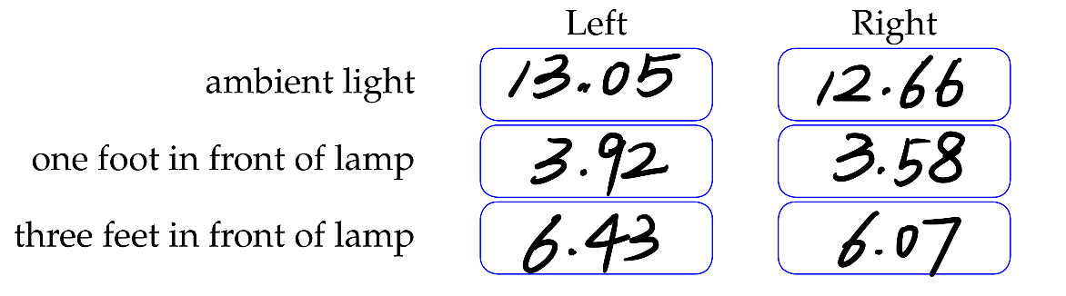

*(2)Design a circuit that uses one photoresistance (plus one or more additional resistances) to generate a voltage that is large under bright conditions and small under dark conditions.*

*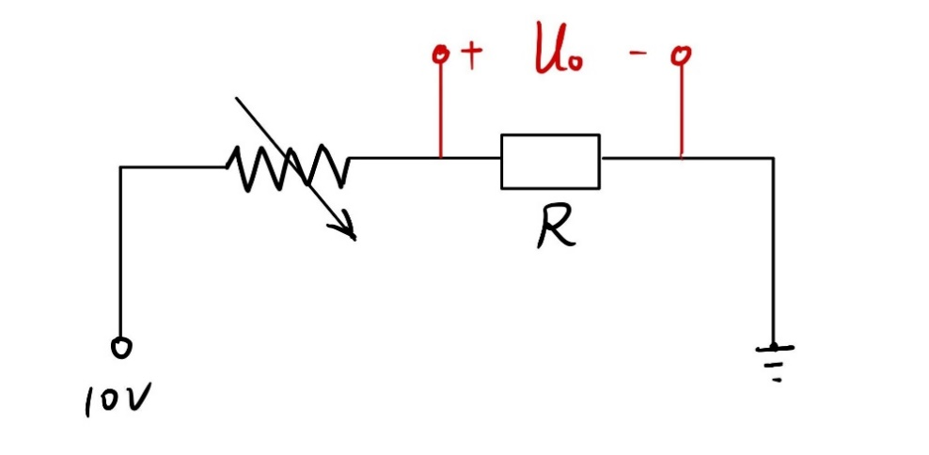****(R=10KΩ)***

*What voltage do you expect for the following lighting conditions?(the scale is marked V)*

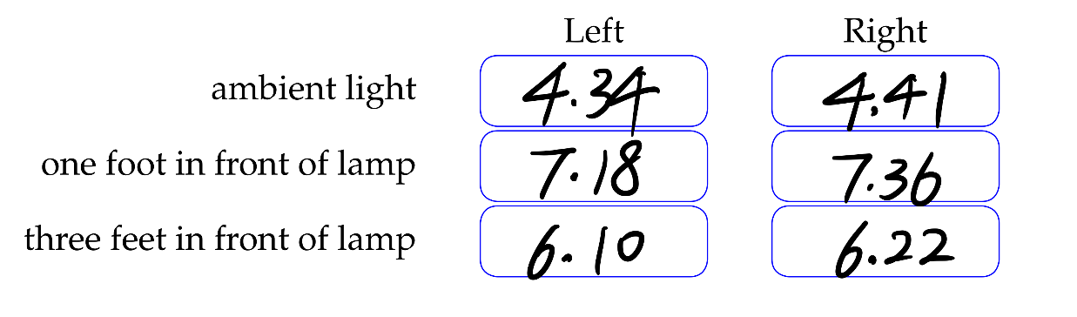

*Check Yourself 4:Explain how your circuit generates a low voltage under ambient conditions and a higher voltage under bright conditions.*

*The photoresistance and the resistance is connected in cascade.When the circuit is under ambient conditions,the value of the photoresistance is relatively large.Therefore, in this case,the voltage obtained across the resistance is relatively small, and my circuit generates a low volage. However,when the circuit is under bright conditions,the value of the photoresistance decreases,and the voltage across the resistance increases,and my circuit generates a high voltage.*

*(3) Draw a schematic for two photoresistance circuits, one to generate the voltage VL from the left photoresistance and one to generate the voltage VR from the right photoresistance, using pins 4, 5, and 6 on the head connector.*

***·*** *First,* *if we consider the ideal case:’the characteristics of the two photoresistance are completely same’，then the schematic is as followed:*

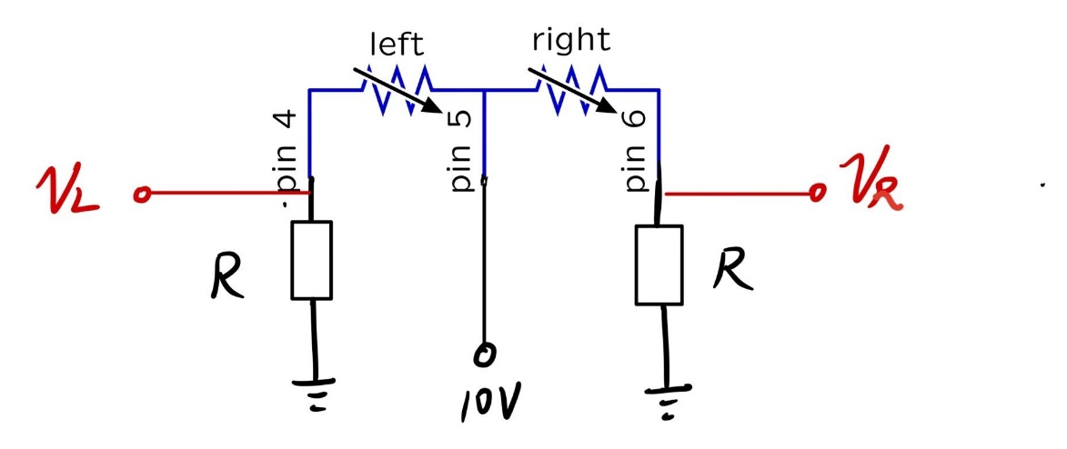

***·*** *In fact,the characteristics of the two photoresistance are different,just as we measured in step4.When the light intensity is same,the value of the left photoresistance and the right photoresistance differ.Therefore,* *according to the actual situation, we improved the design scheme.*

*To compensate the difference between the two photoresistors, the first thing we need to do is to use two potentiometers to adjust it.The circuit is as followed.*

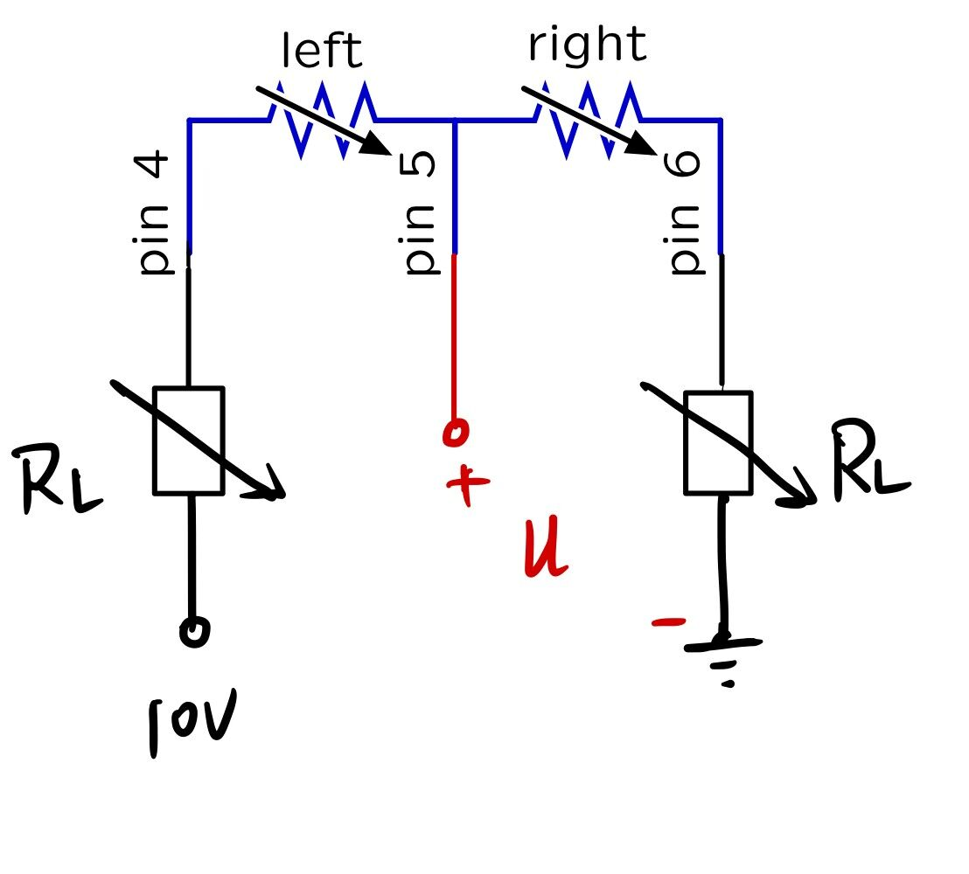

*We use a multimeter to measure U.* *Make U=5V by adjusting the value of RL. After that, we design a new circuit:*

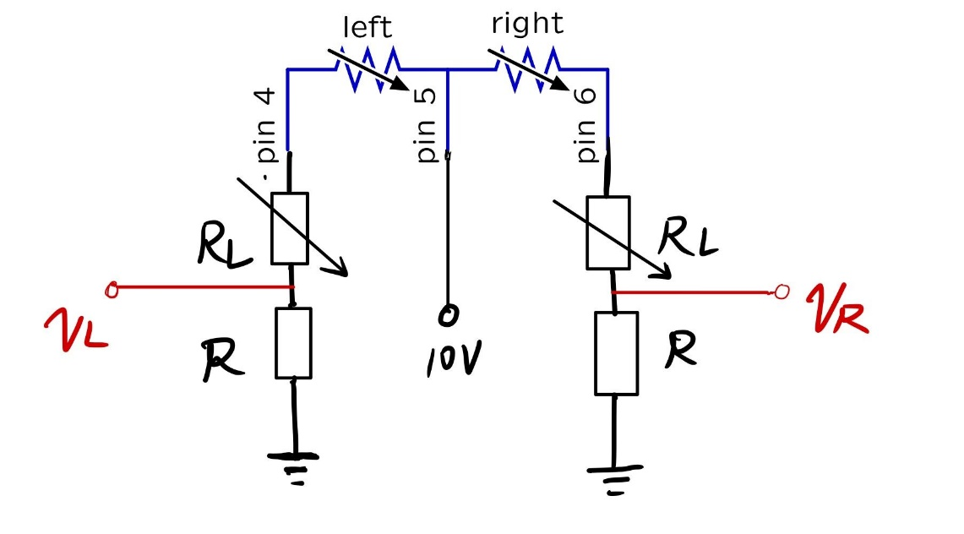

*Compared with the circuit without potentiometer,this circuit is better* [*under the practical circumstance*](https://dict.youdao.com/w/eng/under%20the%20practical%20circumstance/?spc=under%20the%20practical%20circumstance#keyfrom=dict.typo)*.*

*(4)Use Cmax to lay out the circuit and test it*

*(In simulation,we assume that the parameters of the photoresistor are symmetrical,so we use the first circuit design)*

***Measure VL****:*

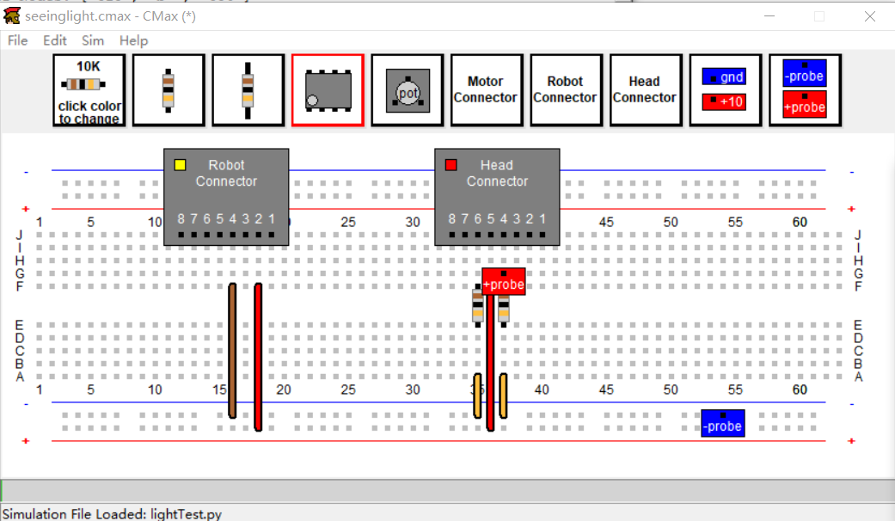

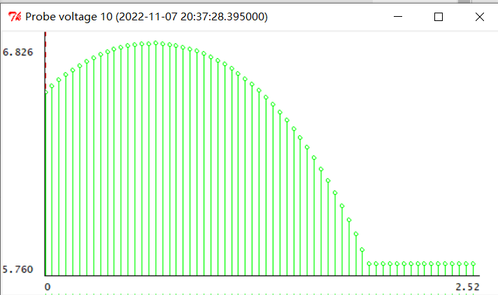

***Measure VR:***

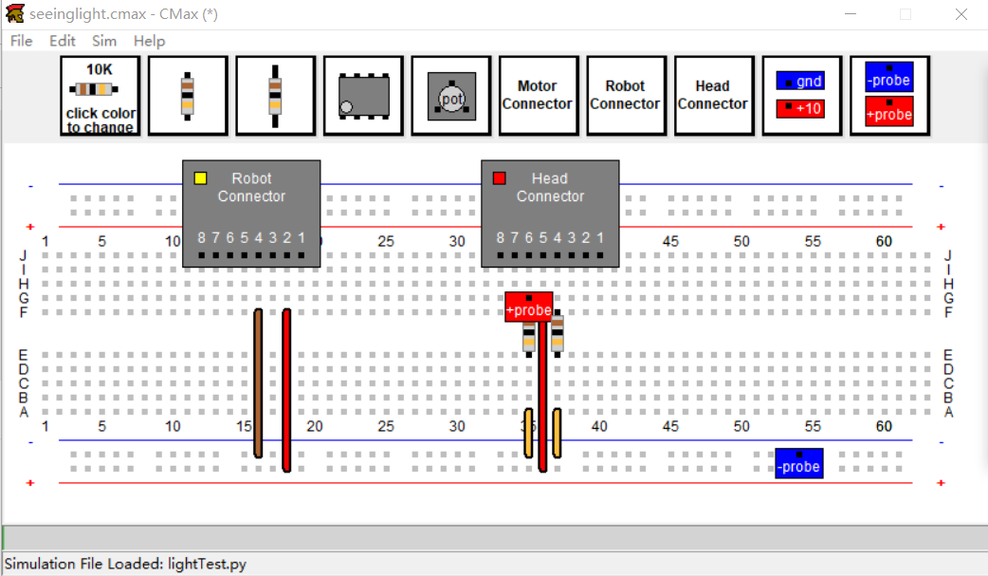

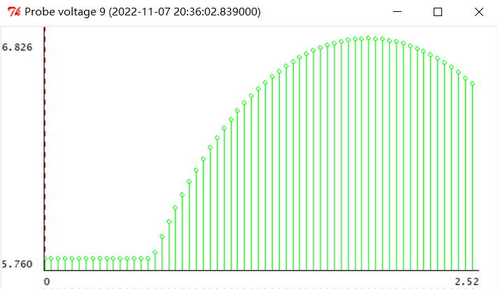

***Measure VL-VR:***

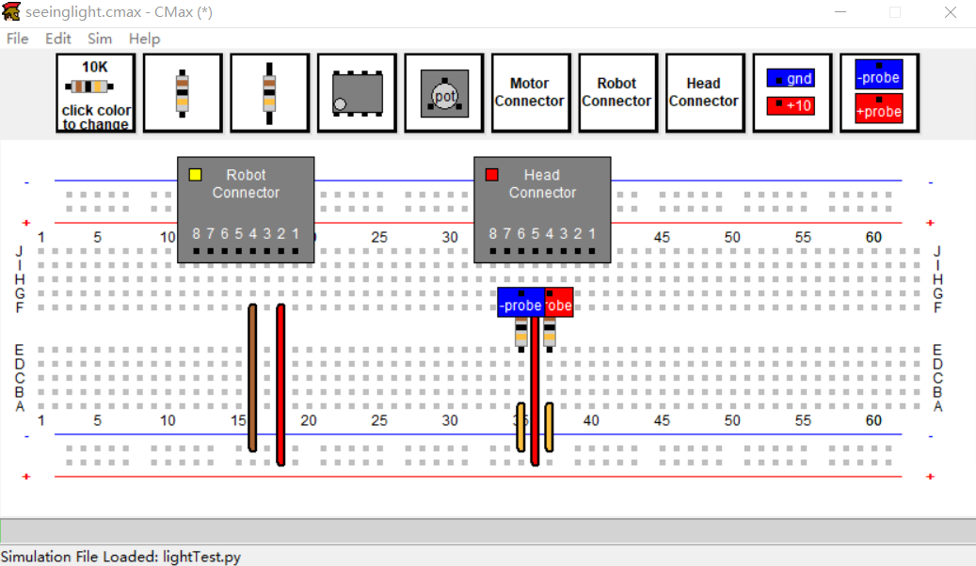

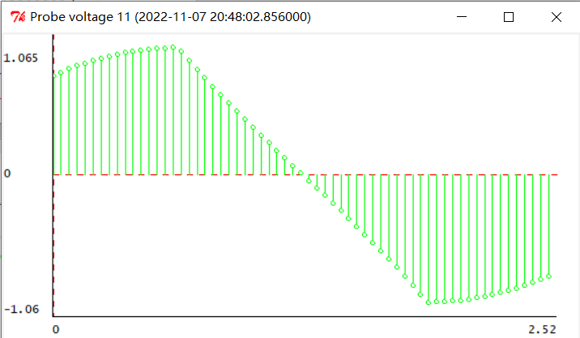

*Check Yourself 5: How should each of the measured voltages change as the light moves from left to right?*

*As the light moves from left to right:*

*The value of VL gradually increases at first.* *After it increases to the maximum, it starts to decrease and then remains.*

*The value of VR remains at first, and then gradually increases.After it increases to the maximum,it starts to decrease.*

*The value of VL-VR increases at first.After it increase to the maximum(A),it gradually decreases.After it decreases to the minimum(-A),It starts to increase again.*

***Summary***

*This experiment is the basic circuit experiment.* *In the part of the simulation and the circuit-designing, we understand the characteristics of voltage divider, and master how to design a voltage divider using photoresistor. The purpose is to convert the change of light intensity into the specific change of the output voltage, and ultimately achieve the light control of the robot.*

*In the part of experimental measurement, the focus is to measure the relationship between the resistance value of photosensitive resistance and the light intensity。*

*Problems in experiment:  
1.First of all, it is difficult to make two photoresistors with identical characteristics in the production process.Therefore, the parameters of the two photoresistors on the robot head are not symmetrical.In order to achieve better results,we can not use only two resistors to complete the experimental requirements as simulation.* *Our solution is to use two potentiometers connected to the two photoresistors in cascade，One end of No.1 potentiometer is connected to pin 4, the other end is connected to 10V power supply. One end of No. 2 potentiometer is connected to pin 6, and the other end is grounded.* *A wire is drawn from pin 5 to measure the voltage to ground at this point (****U****).The asymmetry of the parameters can be reduced by adjusting the two potentiometers so that U=5 when the left and right photoresistors are exposed to the same light. (Using only one potentiometer here may not work, as we do not know which photoresistor has the greater resistance under the same lighting conditions).*

*2.* *In addition, there are also problems in measuring the light and dark resistance data of photosensitive resistor. When the light source is one foot in front of the photoresistor and three feet in front of the photoresistor, there is a certain error in this data due to ambient light. To reduce this error, we should try to turn a light source on or off in a dark environment.*